**Evaluation**

A screenshot of the confusion matrix can be seen below:

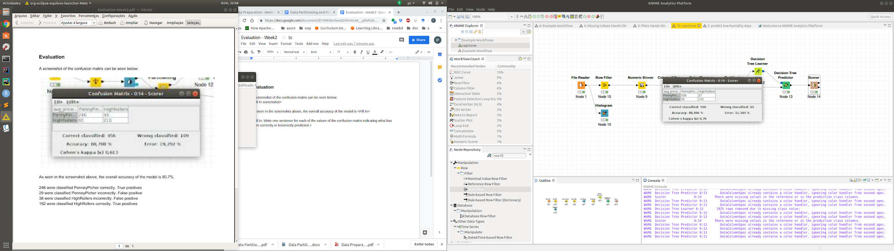

As seen in the screenshot above, the overall accuracy of the model is ~88,5%

246 were classified PenneyPicher correctly. True positive

29 were classified PenneyPicher incorrectly. False positive

38 were classified HighRollers incorrectly. False positive

192 were classified HighRollers correctly. True positives